Hi, everyone! So Sabrina’s posts typically focus on indoor activities, so I’m going to take things outside and make my section of the blog a review of the places and things I see on the bike. Some of my favorite blogs are ride reviews, so I also hope to add to the pool of cycling knowledge out there with my blog entries!

For my first post, I’ll take you back to one of my all-time favorite rides- the Epic Attack on Mt Mitchell out of Asheville, NC (not to be confused with the assault on Mt Mitchell, which is easier and starts out of Spartanburg, SC).

Asheville is one of the more funky places in the south- if you stop by, make sure to try the craft brews and visit the Biltmore Estate!

Anywho, the Attack is also one of the more difficult rides I’ve ever done. From where I started in West Asheville, it was 125 miles and 11,900 ft of climbing, some of it fairly steep.

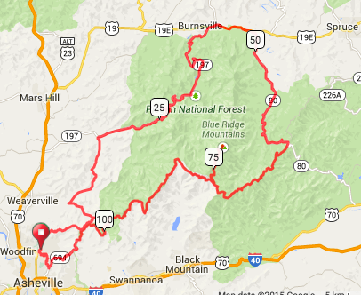

Out of downtown Asheville (2,000 ft, park at Ira Jones Elemeantary), the ride takes you almost immediately up Elk Mountain Scenic Highway. Elk Mountain is a fun climb- lots of twisties, light traffic given the proximity to town, and great views back at Asheville through the trees. It’s a steady 6-7%, a bit under 7 miles up to ~3,500 ft.

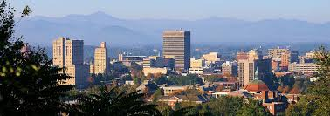

(view of Asheville climbing out on Elk Mtn Rd)

Elk Mountain actually parallels the Blue Ridge Parkway 50 years away at the top of the climb, but don’t get confused if your GPS tries to lead you astray- follow Ox Creek down the north side of the Blue Ridge away from the Parkway, all the way down back to 2,000 ft into the backcountry. Pro tip- there’s a water fountain at the Gov. Vance Birthplace in A few miles of at river grade later is the first real ball-buster of the day- turn onto Maney Branch Rd and be ready for about 1.5 miles at 10+% to the top of Paint Fork Gap. My GPS topped out at 18%. It’s short, steep and sweet. The decent is just as steep and twisty. It’s heavily wooded, so the road was still covered in dew when I hit it around 10:30 am- take it easy.

On the other side, a few more miles at river grade await as you head into Barnardsville (mile 19, Sabrina went to Barnard College). Head along SR197 East and after a few miles, it’ll tilt up again as you go up Ivy Gap- 4,200 ft. The tree cover builds up a lot, the climb isn’t too steep-4 miles ~6% max, but you lose the pavement for a few miles until the top. The gravel is doable with light wheels and a road bike, but take it easy. At the top, you get the pavement back for a fun decent with sweeping curves. SR197 levels out at around 2,800 feet, then it’s flattish to Burnsville- mile 44. In Burnsville, it is HIGHLY recommended that you stock up on food and drinks- there’s no food and almost no water until the end of the ride. There’s a gas station at the junction of 197 and 19E if you don’t want to get off the route.

After a few miles of crap on busy US19E, turn off at Micaville onto SR80 for the flattest 15 miles of the ride along a quiet creek. At mile 59, the grade rachets up a bit, but not too much for a few miles to the top of Wagon Wheel Gap (3350 ft, mile 62)- the crest of the Blue Ridge and the Eastern Continental Divide.

Don’t be fooled, the climbing is far from over! From Wagon Wheel, you finally get on to the Blue Ridge and keep climbing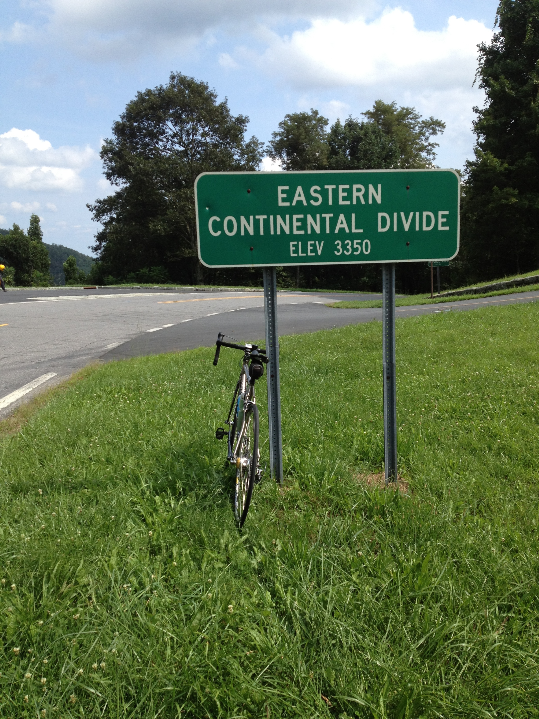. The parkway goes up a few hundred feet, down a hundred, back up, slowly gaining elevation. The parkway climbs at a steady 5-6% with sweeping curves and incredible views of the valley below. But it’s a lot of elevation, there are no services or even houses (protected land), and the climbing is draining after 60+ miles already in the saddle.

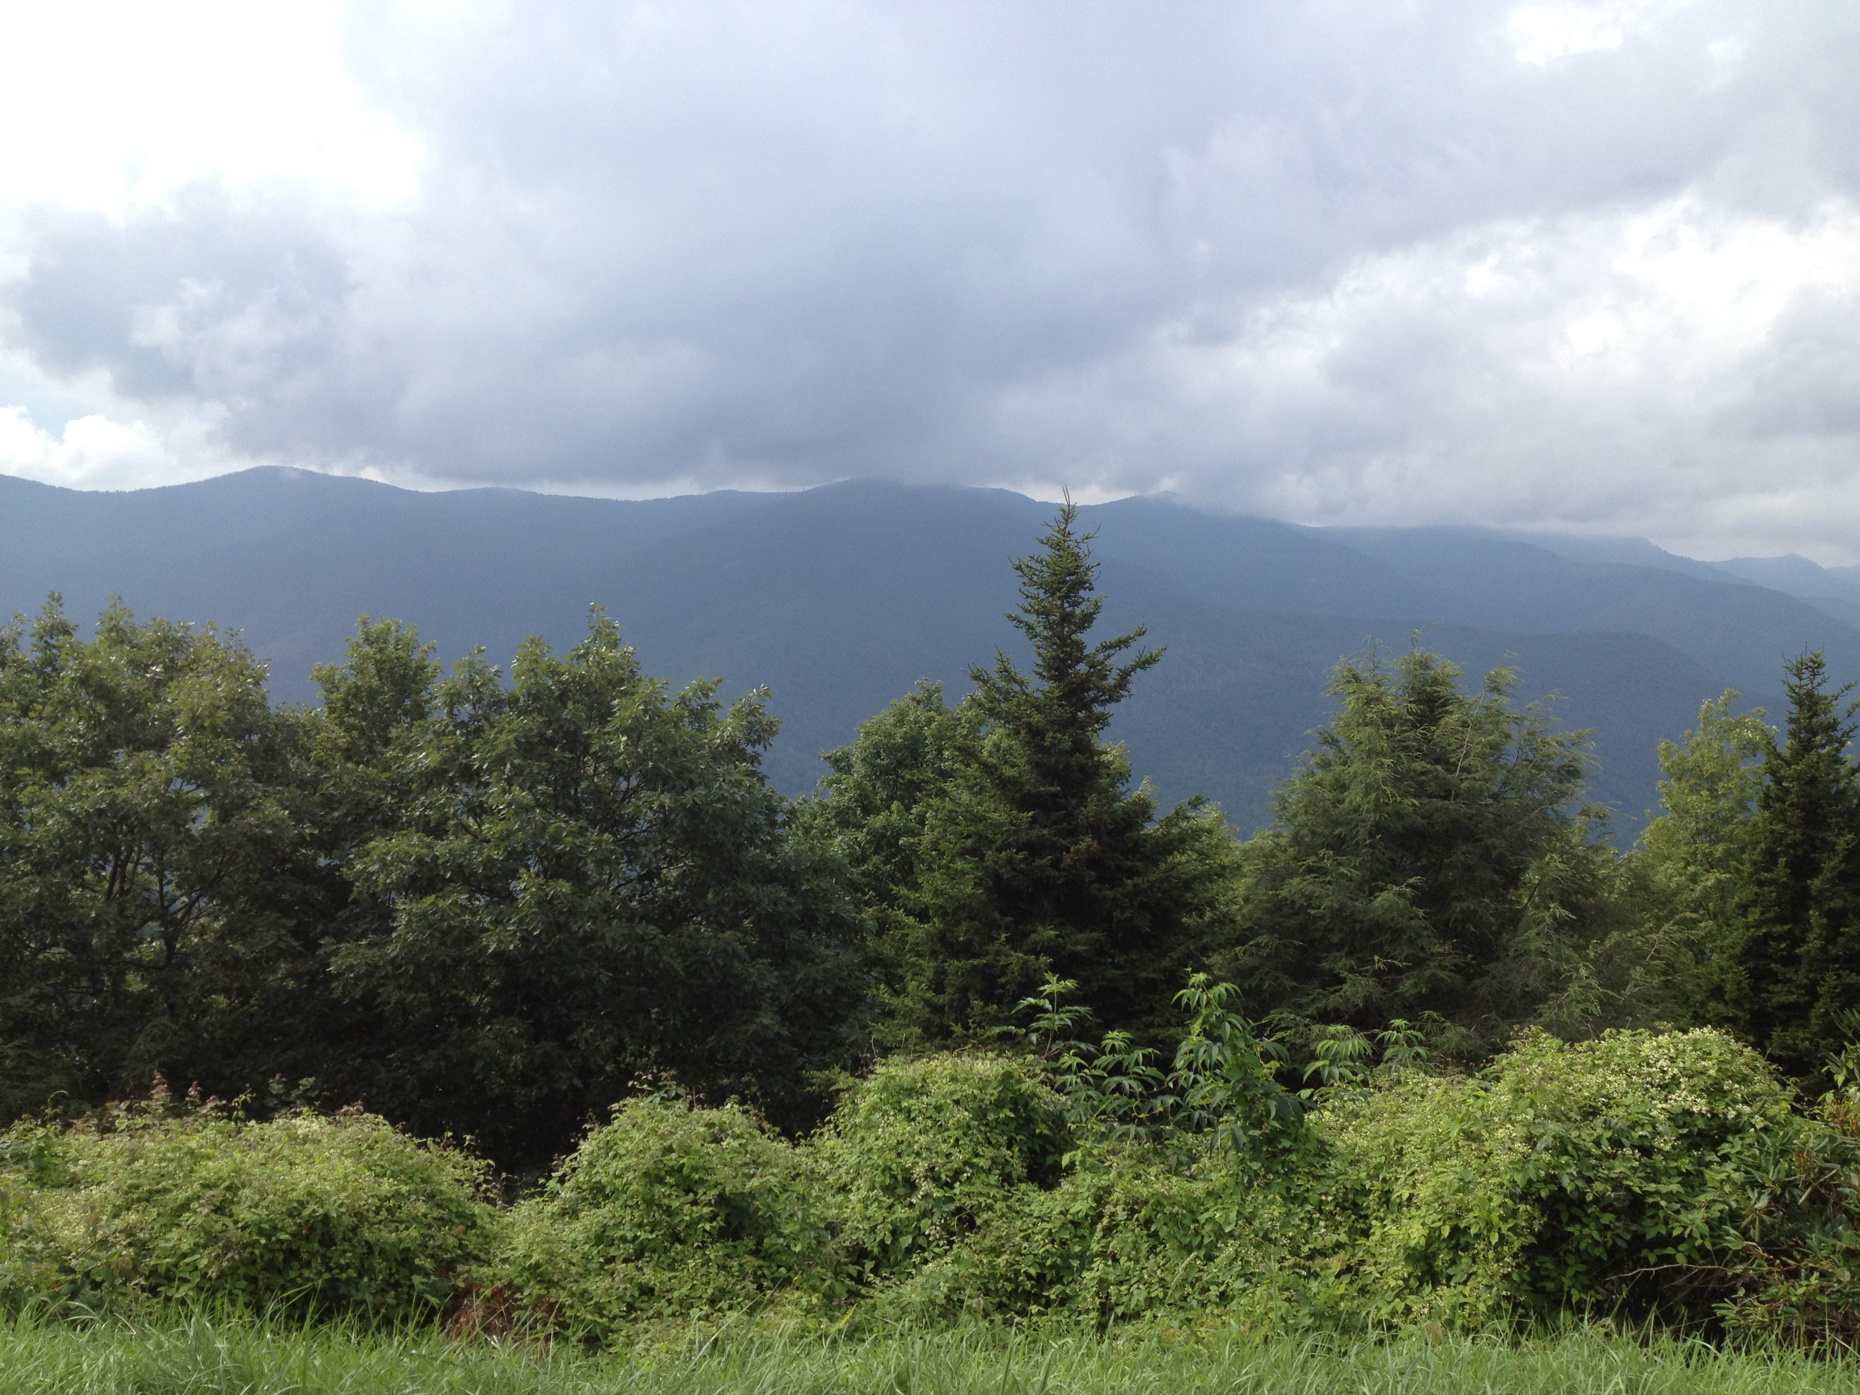

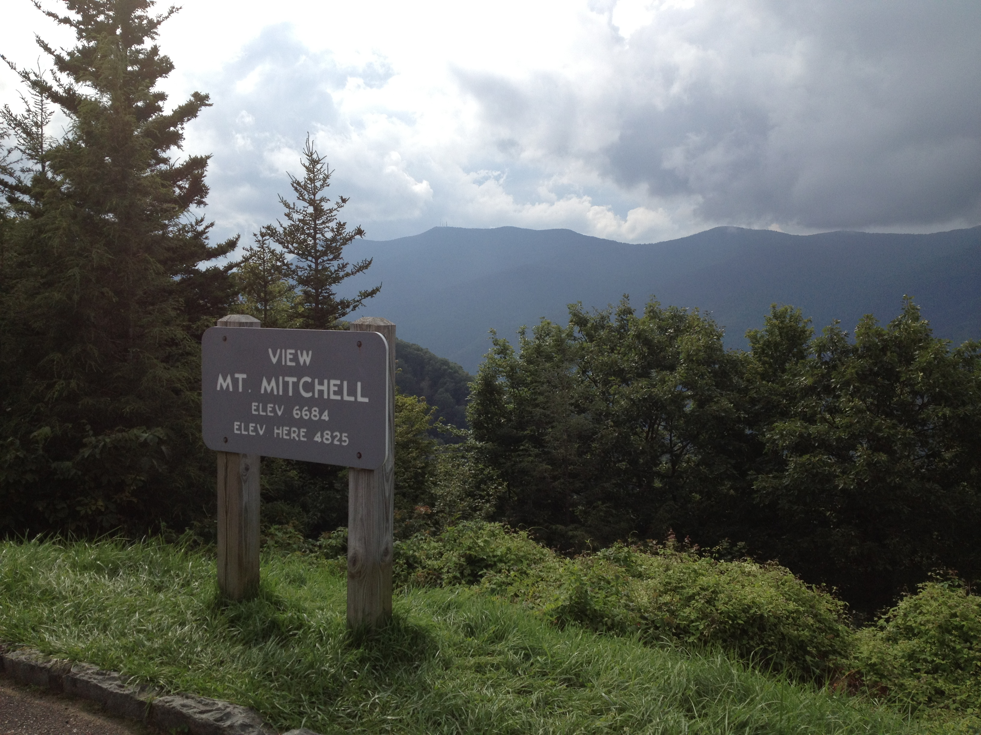

At Mile 73, you’ve climbed over 5,000 ft on the Parkway, and you have the option to climb Mt Mitchell. It’s an out and back- 5 miles each way, 5%, sweeping views up to the summit, which is the highest point in the east at over 6,500 ft. The view from the top is worth it. There is also a water fountain at the top, the first water since Burnsville. 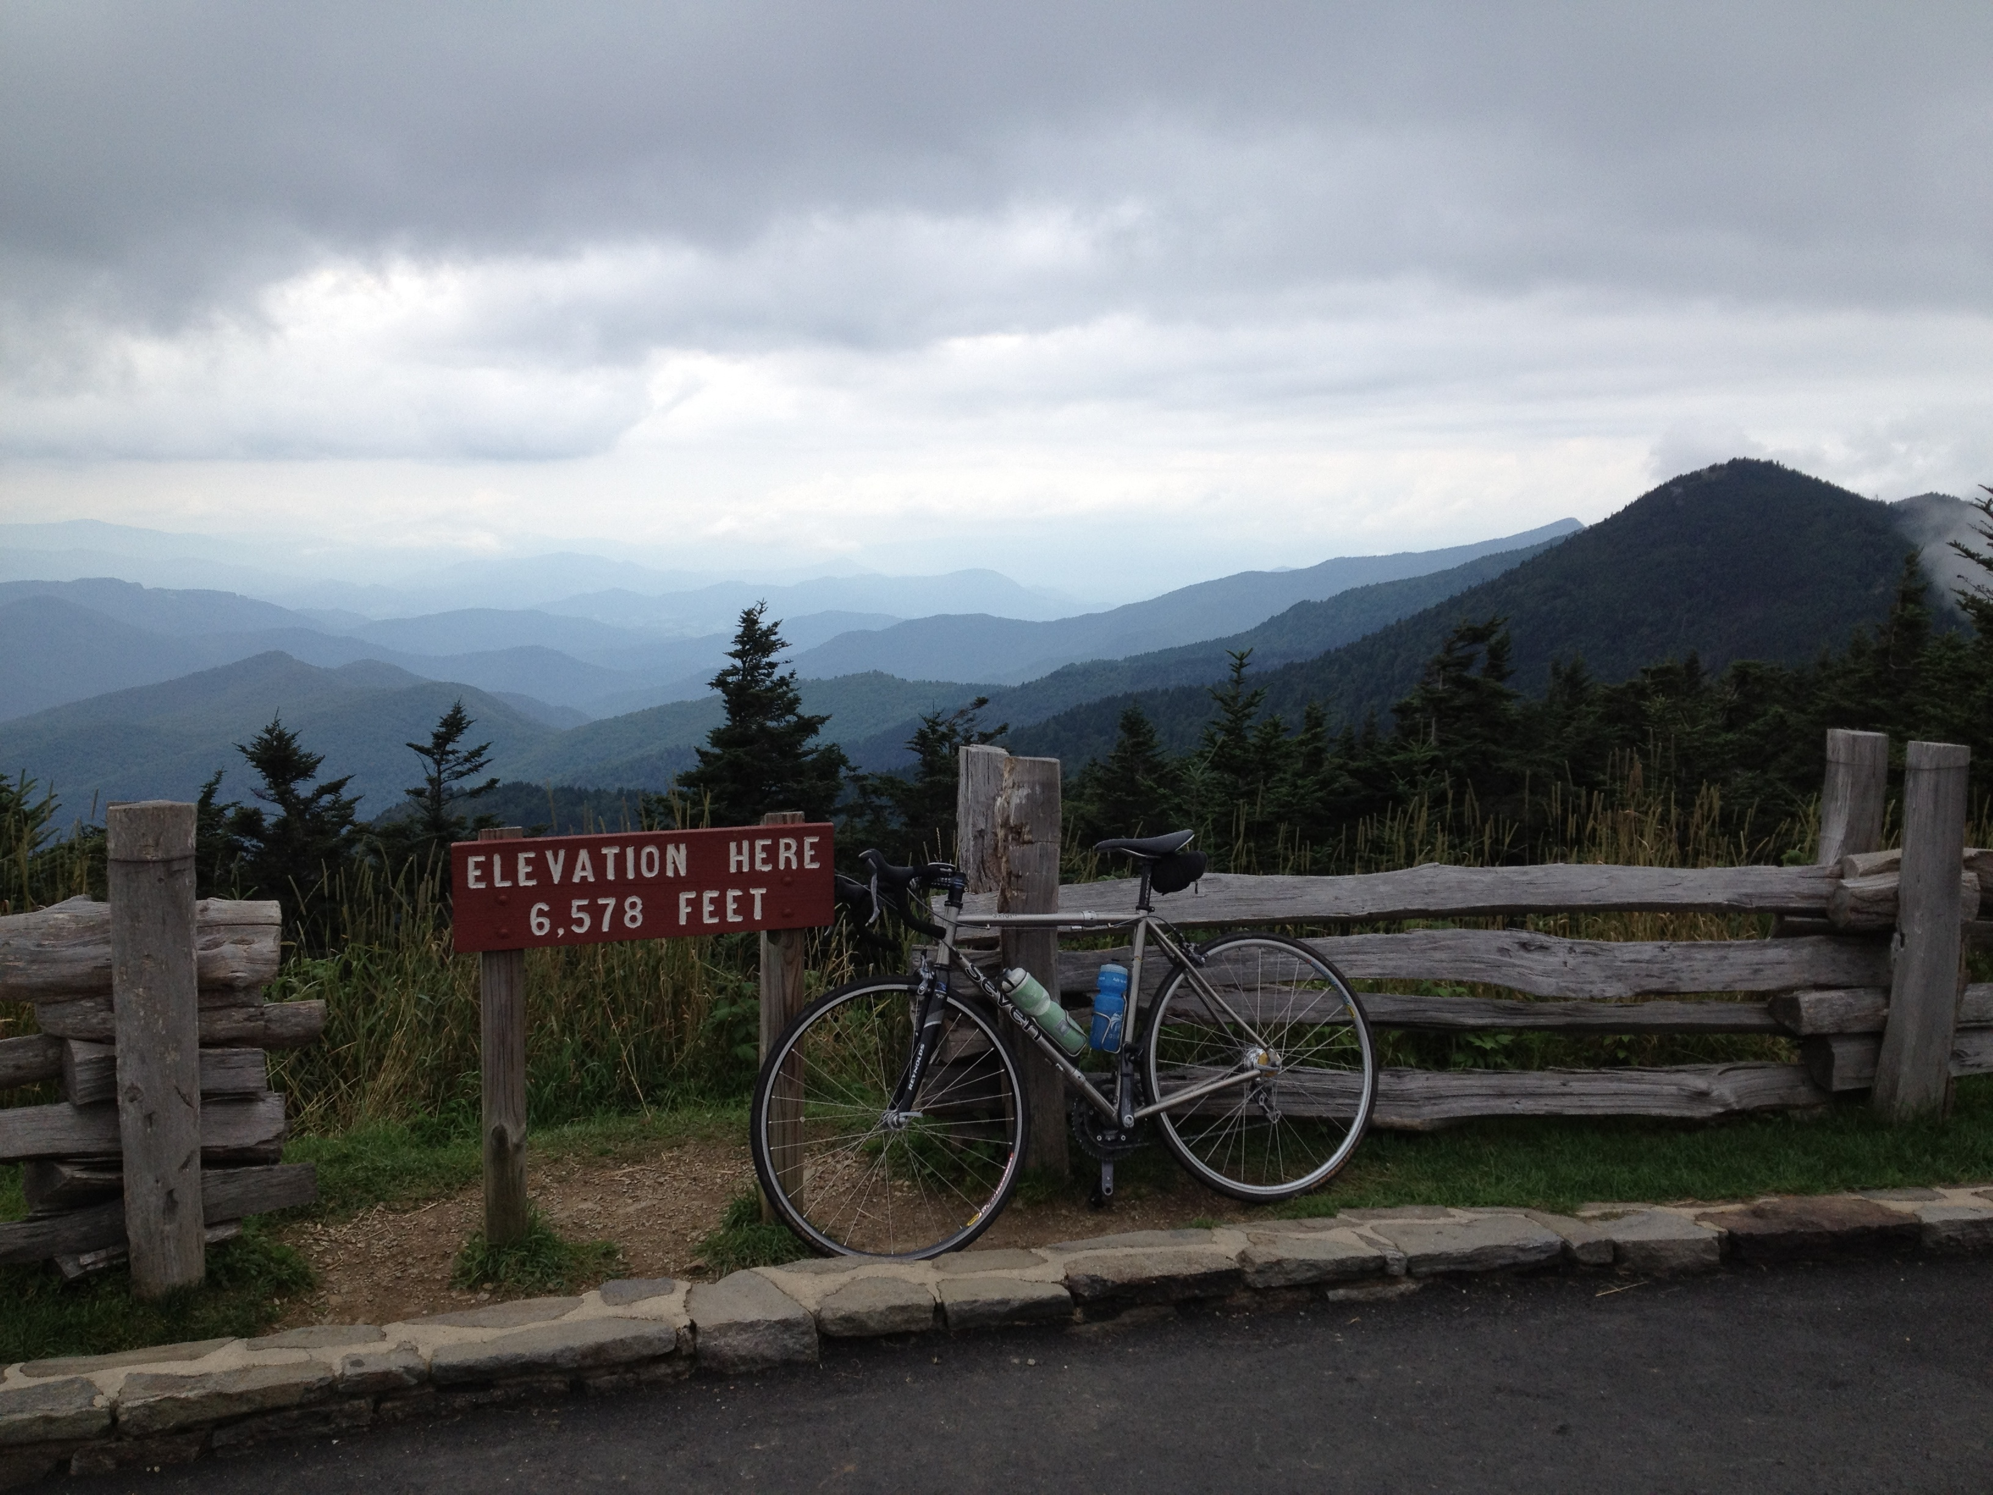

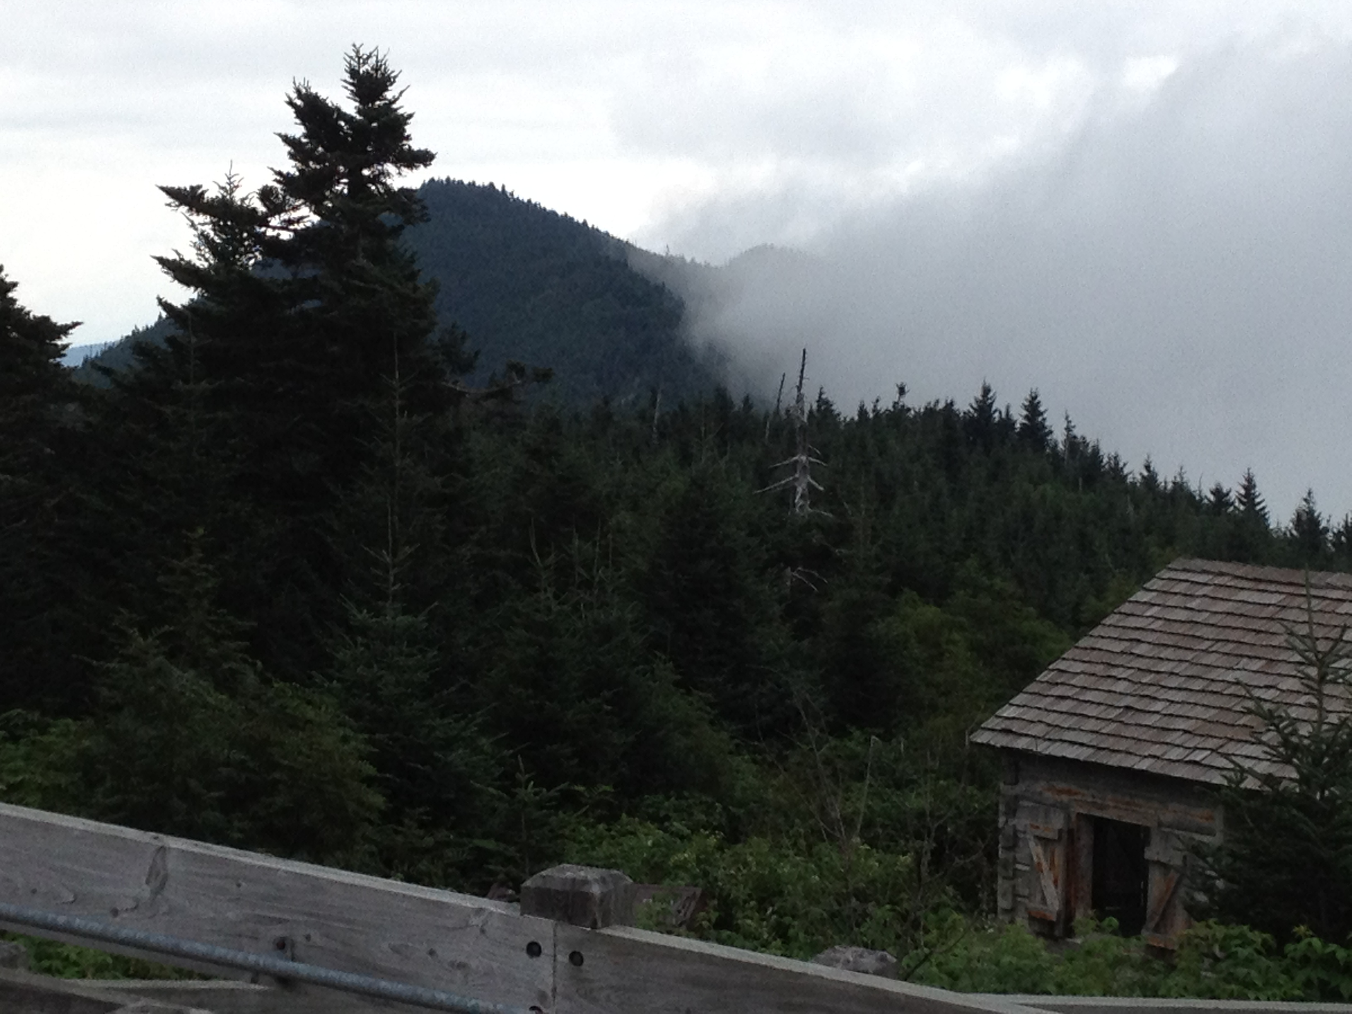

At t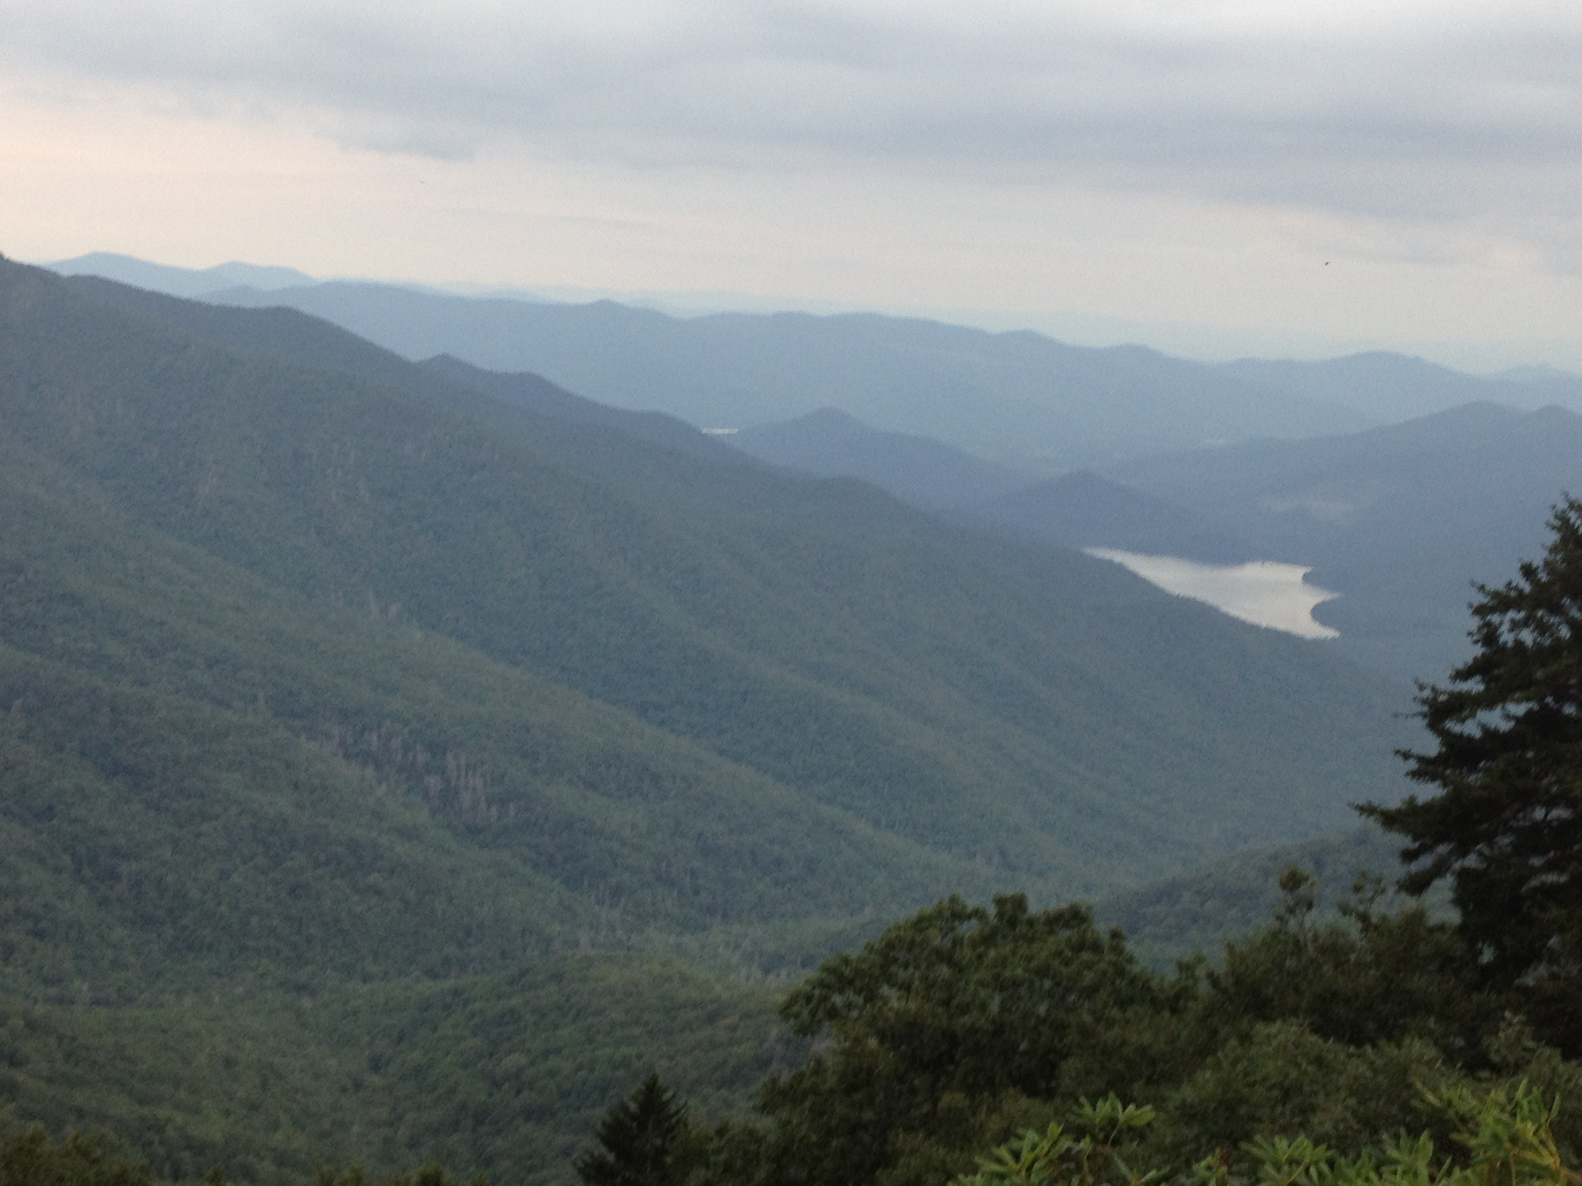he top, enjoy the view, but the climbing isn’t over. After the decent back down to the Parkway, you descend the last 30 miles back to Asheville the same way as the climb up- down 1000 ft, up 400 feet, back down, all the way. Pesky climbs when you’re already beat and haven’t eaten in too long. When I did this ride, I hadn’t realized that there would be so few services, so my blood sugar levels were pretty low by the time I got to the top of Mt Mitchell, let alone back down to Asheville. The view of the Burnett Reservoir and Craggy Gardens are pretty cool from the Parkway, though.

If you make it back to Asheville in one piece, congrats! Any rides over 100 miles and 10K in climbing are pretty tough, and this one more than qualifies. Throw in the lack of services after mile 44 and you also have to plan appropriately. That said, the views are fantastic, roads very quiet (although avoid the Parkway during peak weekends, like foliage season). Highly recommended, but not for the faint of heart!